Can an Architect help your Fort Worth Remodel?

I know what you're thinking: Architects are way too expensive and only necessary when building homes or Whole House Renovations. The truth is, architects are well worth the extra cost on any remodeling job because with thoughtful evaluation and design, they can meet--and often exceed--your expectations. In fact, depending on the size or complexity of the remodeling, calling in an architect might be the only way to get the project off the ground, and to ensure your dream comes true.

**See the Big Picture**

An architect has the training and skill to produce a detailed design based on your particular needs and desires--a design that's sensitive to the architecture of your existing home, and scaled to the proper proportions. However, what truly makes an architect valuable is the ability to develop and refine a vision of the completed project that you can see and understand. And architects are experts at seeing not only the big picture, but also the hundreds of tiny steps between concept and completion.

Design/Build Remodeling, Fort Worth

The fastest growing segment of residential design remodeling is, One- stop shops who will design and build your project and provide supervision throughout every phase of construction. This option also saves you the trouble of negotiating and signing two contracts--one with an architect and another with the contractor. It's also important that you be involved during the process, even if it's j to convey your experiences and more importantly will address any hot buttons you may have. This way, you'll be able to express your concerns as the project takes shape with your team without surrendering all control, you want to make sure your needs and desires are satisfied.

But be aware that some design-build firms and certified architects fall short in their performance, “After all, if your home has a flaw the previous architect and builder signed off on it”.

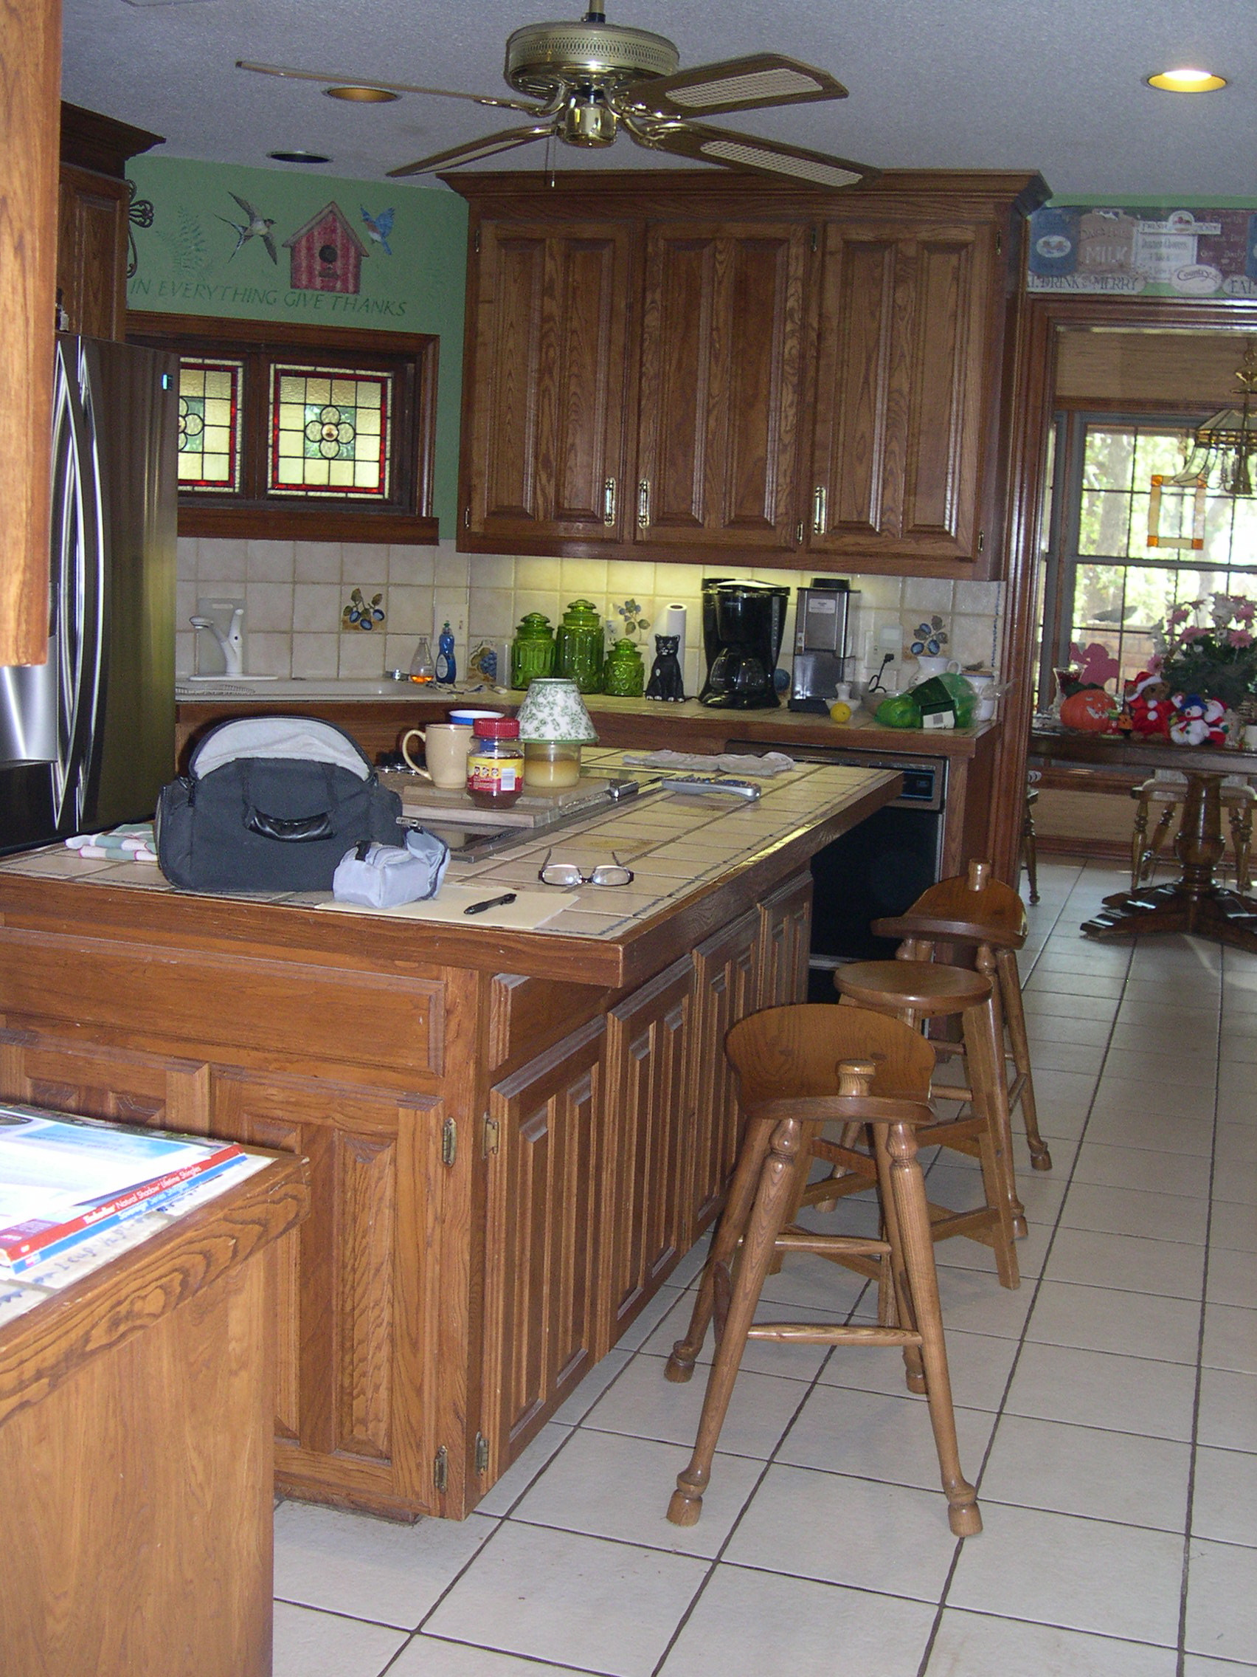

Before- Fort Worth Kitchen remodel

After- Fort Worth Design Remodel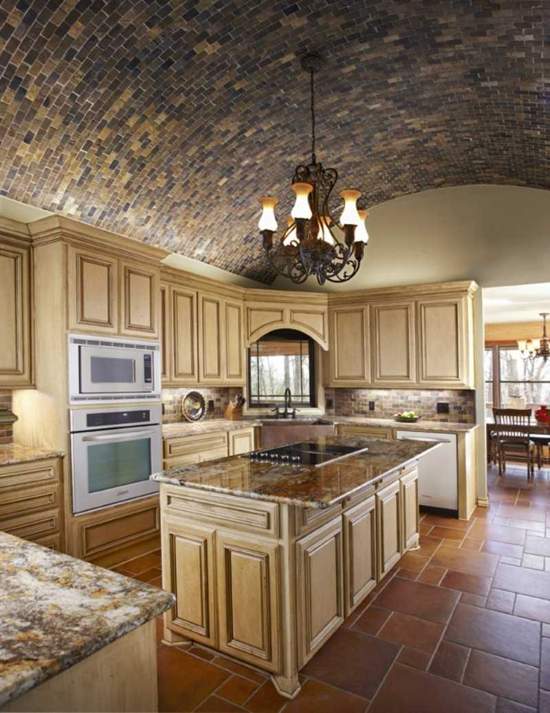

Building value with superior remodel planning.

About Us

USI Design & Remodeling is a “Best of the Best”, award winning kitchen and bath remodeling specialist. We help clients build the right way by planning our results using on time one source delivery.